**Week 5(Microservices)**

**Exercise 1: Creating Microservices for account and loan**

C:\Users\ayush\Downloads\6428577_Ayush_Raj\microservices

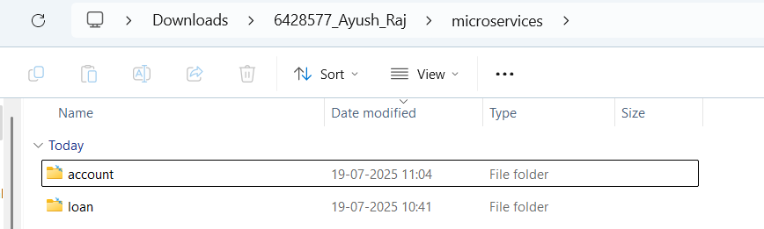

**//account**

**/pom.xml**

<project xmlns=*"http://maven.apache.org/POM/4.0.0"*

xmlns:xsi=*"http://www.w3.org/2001/XMLSchema-instance"*

xsi:schemaLocation=*"http://maven.apache.org/POM/4.0.0 https://maven.apache.org/xsd/maven-4.0.0.xsd"*>

<modelVersion>4.0.0</modelVersion>

<parent>

<groupId>org.springframework.boot</groupId>

<artifactId>spring-boot-starter-parent</artifactId>

<version>3.5.3</version>

<relativePath/> <!-- lookup parent from repository -->

</parent>

<groupId>com.cognizant</groupId>

<artifactId>loan</artifactId>

<version>0.0.1-SNAPSHOT</version>

<name>loan</name>

<description>Loan microservice for Spring Boot</description>

<properties>

<java.version>17</java.version>

</properties>

<dependencies>

<dependency>

<groupId>org.springframework.boot</groupId>

<artifactId>spring-boot-starter-web</artifactId>

</dependency>

<dependency>

<groupId>org.springframework.boot</groupId>

<artifactId>spring-boot-devtools</artifactId>

<scope>runtime</scope>

<optional>true</optional>

</dependency>

<dependency>

<groupId>org.springframework.boot</groupId>

<artifactId>spring-boot-starter-test</artifactId>

<scope>test</scope>

</dependency>

</dependencies>

<build>

<plugins>

<plugin>

<groupId>org.springframework.boot</groupId>

<artifactId>spring-boot-maven-plugin</artifactId>

</plugin>

</plugins>

</build>

</project>

**//AccountController.java**

**package** com.cognizant.account.controller;

**import** org.springframework.web.bind.annotation.*;

@RestController

@RequestMapping("/accounts")

**public** **class** AccountController {

@GetMapping("/{number}")

**public** Account getAccount(@PathVariable String number) {

**return** **new** Account(number, "savings", 234343);

}

**static** **class** Account {

**public** String number;

**public** String type;

**public** **double** balance;

**public** Account(String number, String type, **double** balance) {

**this**.number = number;

**this**.type = type;

**this**.balance = balance;

}

}

}

**// AccountApplication.java**  
**package** com.cognizant.account;

**import** org.springframework.boot.SpringApplication;

**import** org.springframework.boot.autoconfigure.SpringBootApplication;

@SpringBootApplication

**public** **class** AccountApplication {

**public** **static** **void** main(String[] args) {

SpringApplication.*run*(AccountApplication.**class**, args);

}

}

**//application.properties**

spring.application.name=account

# Default port 8080

**Output:**

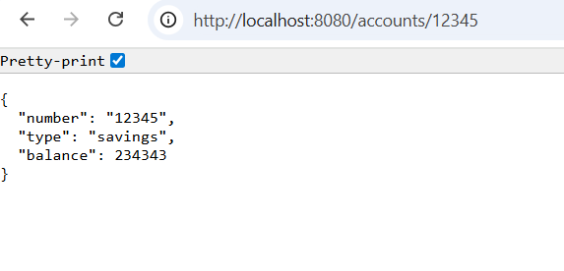

**//loan**

**//pom.xml**

<?xml version=*"1.0"* encoding=*"UTF-8"*?>

<project xmlns=*"http://maven.apache.org/POM/4.0.0"* xmlns:xsi=*"http://www.w3.org/2001/XMLSchema-instance"*

xsi:schemaLocation=*"http://maven.apache.org/POM/4.0.0 https://maven.apache.org/xsd/maven-4.0.0.xsd"*>

<modelVersion>4.0.0</modelVersion>

<parent>

<groupId>org.springframework.boot</groupId>

<artifactId>spring-boot-starter-parent</artifactId>

<version>3.5.3</version>

<relativePath/> <!-- lookup parent from repository -->

</parent>

<groupId>com.cognizant</groupId>

<artifactId>loan</artifactId>

<version>0.0.1-SNAPSHOT</version>

<name>loan</name>

<description>Loan Microservice</description>

<url/>

<licenses>

<license/>

</licenses>

<developers>

<developer/>

</developers>

<scm>

<connection/>

<developerConnection/>

<tag/>

<url/>

</scm>

<properties>

<java.version>17</java.version>

</properties>

<dependencies>

<dependency>

<groupId>org.springframework.boot</groupId>

<artifactId>spring-boot-starter-web</artifactId>

</dependency>

<dependency>

<groupId>org.springframework.boot</groupId>

<artifactId>spring-boot-devtools</artifactId>

<scope>runtime</scope>

<optional>true</optional>

</dependency>

<dependency>

<groupId>org.springframework.boot</groupId>

<artifactId>spring-boot-starter-test</artifactId>

<scope>test</scope>

</dependency>

</dependencies>

<build>

<plugins>

<plugin>

<groupId>org.springframework.boot</groupId>

<artifactId>spring-boot-maven-plugin</artifactId>

</plugin>

</plugins>

</build>

</project>

**// LoanController.java**

**package** com.cognizant.loan.controller;

**import** org.springframework.web.bind.annotation.*;

@RestController

@RequestMapping("/loans")

**public** **class** LoanController {

@GetMapping("/{number}")

**public** Loan getLoan(@PathVariable String number) {

**return** **new** Loan(number, "car", 400000, 3258, 18);

}

**static** **class** Loan {

**public** String number;

**public** String type;

**public** **double** loan;

**public** **double** emi;

**public** **int** tenure;

**public** Loan(String number, String type, **double** loan, **double** emi, **int** tenure) {

**this**.number = number;

**this**.type = type;

**this**.loan = loan;

**this**.emi = emi;

**this**.tenure = tenure;

}

}

}

**// LoanApplication.java**

package com.cognizant.loan;

import org.springframework.boot.SpringApplication;

import org.springframework.boot.autoconfigure.SpringBootApplication;

@SpringBootApplication

public class LoanApplication {

public static void main(String[] args) {

SpringApplication.run(LoanApplication.class, args);

}

}

**//application.properties**

spring.application.name=loan

server.port=8081

**Output:**

